5.57: In the absence of friction, the only forces along the ramp are the component of the weight along the ramp, 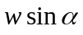, and the component of 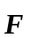 along the ramp, 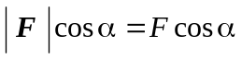. These forces must sum to zero, so 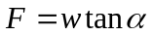.
Considering horizontal and vertical components, the normal force must have horizontal component equal to 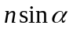, which must be equal to F; the vertical component must balance the weight, . Eliminating n gives the same result.

